6. FUNCTIONAL AND PERFORMANCE TESTING:
The Courier Management System was tested to verify that the implemented Salesforce features function correctly and reliably. Testing was carried out on record creation, validation rules, flow automation, access control, reports, and dashboard visualization.
6.1 Testing Areas:
The following testing areas were considered during the implementation of the Courier Management System.
Test Area | Verification Focus
Record Creation | Verify that Customer, Shipment, Delivery Agent, Branch, Delivery Update, and Invoice records can be created and saved successfully.
Validation Rules | Verify that invalid or incomplete information is rejected with appropriate error messages.
Flow Automation | Verify that a Delivery Update automatically synchronizes the related Shipment status.
Access Control | Verify that configured profiles and roles provide the required level of access.
Reports and Dashboard | Verify that reports and dashboard components display the configured courier information correctly.

- 6.1 – Record Creation Testing:

Field | Sample Value
Tracking Number | CMS10001
Customer | Arun Kumar
Source Address | Chennai, Tamil Nadu
Destination Address | Coimbatore, Tamil Nadu
Weight | 2.5 kg
Price | ₹350
Status | In Transit
Expected Delivery Date | 30-Sep-2026
Assigned Agent | Ravi Kumar

Shipment Management:
Shipment management was tested by creating shipment records containing tracking information, source and destination addresses, weight, price, status, expected delivery date, and assigned delivery agent.
- 6.3 – Shipment Record Testing:
Field | Sample Value
Tracking Number | CMS10001
Customer | Arun Kumar
Source Address | Chennai, Tamil Nadu
Destination Address | Coimbatore, Tamil Nadu
Weight | 2.5 kg
Price | ₹350
Status | In Transit
Expected Delivery Date | 30-Sep-2026
Assigned Agent | Ravi Kumar

Delivery Agent Management:
Delivery-agent management was tested by creating agent records and assigning available agents to shipments.
- 6.4 – Delivery Agent Record Testing:
Field | Sample Value
Agent Name | Ravi Kumar
Email | ravi.kumar@example.com
Phone | 9876543210
Branch | Chennai Main Branch
Status | Active
Joining Date | 15-Aug-2026
Agent ID | AGT1001

Delivery Updates:
Delivery updates were tested by changing the status of a shipment and recording the update date and remarks.
- 6.5 – Delivery Update Testing:
Field | Sample Value
Update Number | DU10001
Shipment | CMS10001
Tracking Number | CMS10001
Status | Delivered
Update Date | 30-Sep-2026
Remarks | Shipment delivered successfully to the customer
Updated By | Ravi Kumar

Invoice Management:
Invoice management was tested by creating an invoice associated with a shipment. The invoice contains the invoice number, shipment reference, amount, invoice date, and payment status.

- 6.6 – Invoice Record Testing:

Field | Sample Value
Invoice Number | INV10001
Shipment | CMS10001
Tracking Number | CMS10001
Customer | Arun Kumar
Amount | ₹350
Invoice Date | 30-Sep-2026
Payment Status | Paid
Payment Method | Online Payment

Automation:
Salesforce Flow automation was tested by creating a Delivery Update and checking whether the corresponding Shipment status was automatically updated.
- 6.7 Salesforce Flow Automation Testing:

Flow Component | Details
Flow Name | Auto_Update_Shipment_Status
Flow Type | Record-Triggered Flow
Trigger Object | Delivery Update
Trigger Condition | When a Delivery Update record is created
Get Records | Find the related Shipment record
Update Records | Update the Shipment Status
Example Status | Delivered
Related Shipment | CMS10001
Expected Result | Shipment status is automatically updated
Flow Status | Activated
Security:
Security testing was performed to verify that users receive appropriate access based on their configured profiles and roles.
- 6.8 – Profiles and Roles Testing:
Security Component | Sample Configuration
Profile 1 | Courier Admin
Profile 2 | Branch Manager
Profile 3 | Delivery Agent
Profile 4 | Customer Support
Top-Level Role | Courier Admin
Second-Level Role | Branch Manager
Lower-Level Roles | Delivery Agent, Customer Support
Access Control | Based on assigned profile and role
Expected Result | Users can access only the records and features permitted to them
Testing Result | Access permissions verified successfully

Reporting:
Reports were tested to verify that courier information is displayed correctly for analysis and monitoring.
- 6.9 – Report Testing:

Field | Sample Details
Report Name | Shipment Status Summary
Customer 1 | Arun Kumar
Customer 2 | Priya Sharma
Customer 3 | Karthik Raj
Assigned Agent 1 | Ravi Kumar
Assigned Agent 2 | Suresh Babu
Assigned Agent 3 | Manoj Kumar
Tracking Number 1 | CMS10001
Tracking Number 2 | CMS10002
Tracking Number 3 | CMS10003
Status | Delivered / In Transit / Pending
Purpose | Monitor customer shipments and delivery progress
Testing Result | Report data displayed successfully

6.3 Performance Testing:
Performance testing was carried out during normal system operations to verify that the Salesforce application responds correctly when records are created, flows are executed, reports are generated, and dashboards are loaded.
Performance Area | Expected Result
Record Saving | Records should be saved successfully without unnecessary delays.
Flow Execution | Automated status updates should execute correctly after a Delivery Update is created.
Page Loading | Salesforce pages should load properly during normal usage.
Report Generation | Reports should display the configured data correctly.
Dashboard Loading | Dashboard components should load and display operational information properly.

- 6.10 Performance Testing Dashboard:
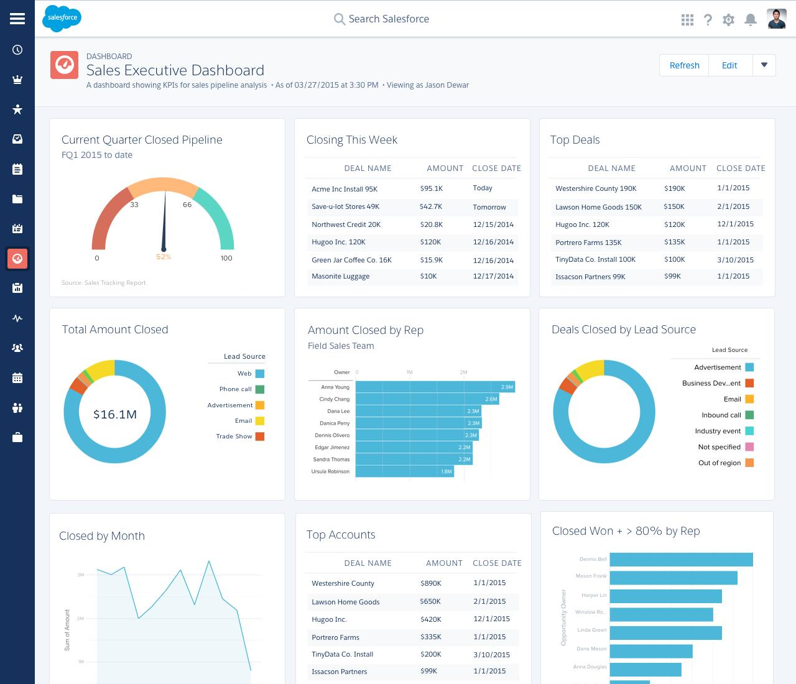
6.4 Testing Result:
The implemented testing scenarios were validated for correct functionality and reliability. The system successfully demonstrated customer management, shipment management, delivery-agent assignment, delivery-status updates, invoice management, validation rules, Salesforce Flow automation, role-based access, report generation, and dashboard visualization.
The screenshots included in this chapter provide visual evidence of the implemented Salesforce features and their successful operation. The testing results indicate that the Courier Management System performs the required operations correctly under normal usage conditions.

